(Your Church’s name) presents
Rev. Craig A. Lantz's
Magic Ministry
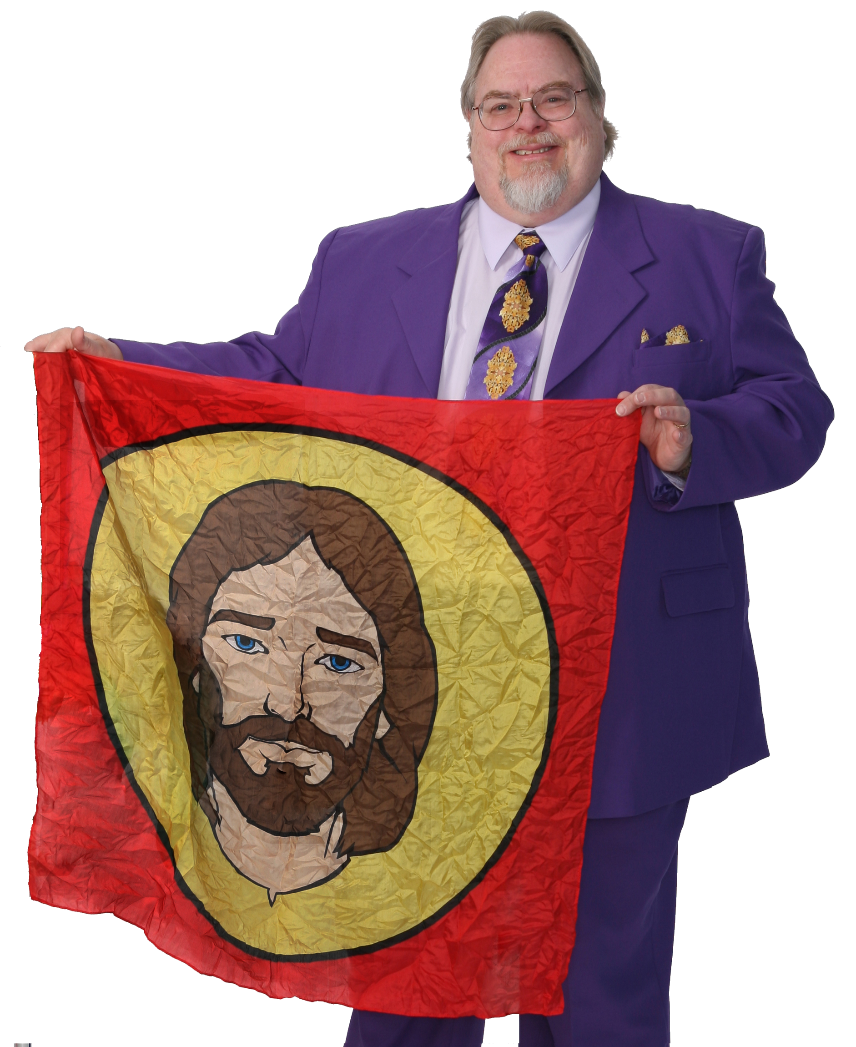
Date:
Time:
Location:

